AMSTI User Manual

Contents

**AMSTI Web Pages** 2

**AMSTI Site Map** 7

**Web Service Access** 7

**The Forms Database** 8

**Newsletter** 8

# **AMSTI Web Pages**

Upon visiting the website, <http://myathensric.org/>, you are greeted with the home page.

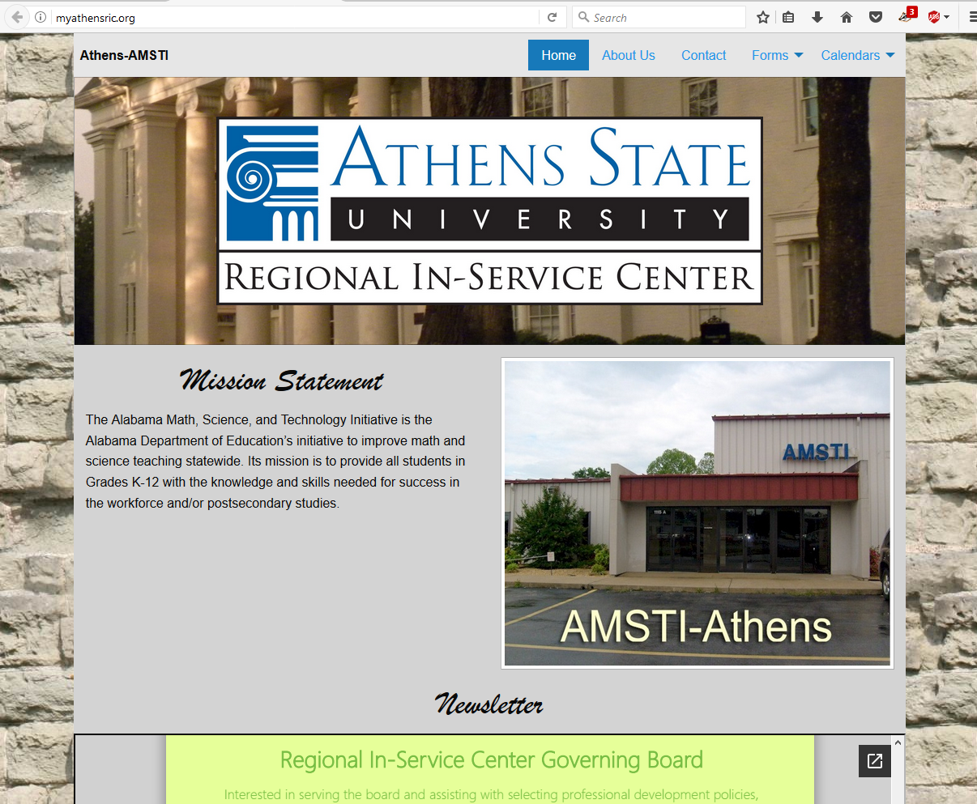

Figure - The Home Page Note: You will have to scroll down to view its entire contents.

You can view the other pages by using the navigation links. These links are found at the top right of the page.



Figure - The Navigation Bar

The About Us page describes the purpose of the AMSTI organization. Navigate to the About Us page by clicking on the About Us link. The About Us page is as follows:

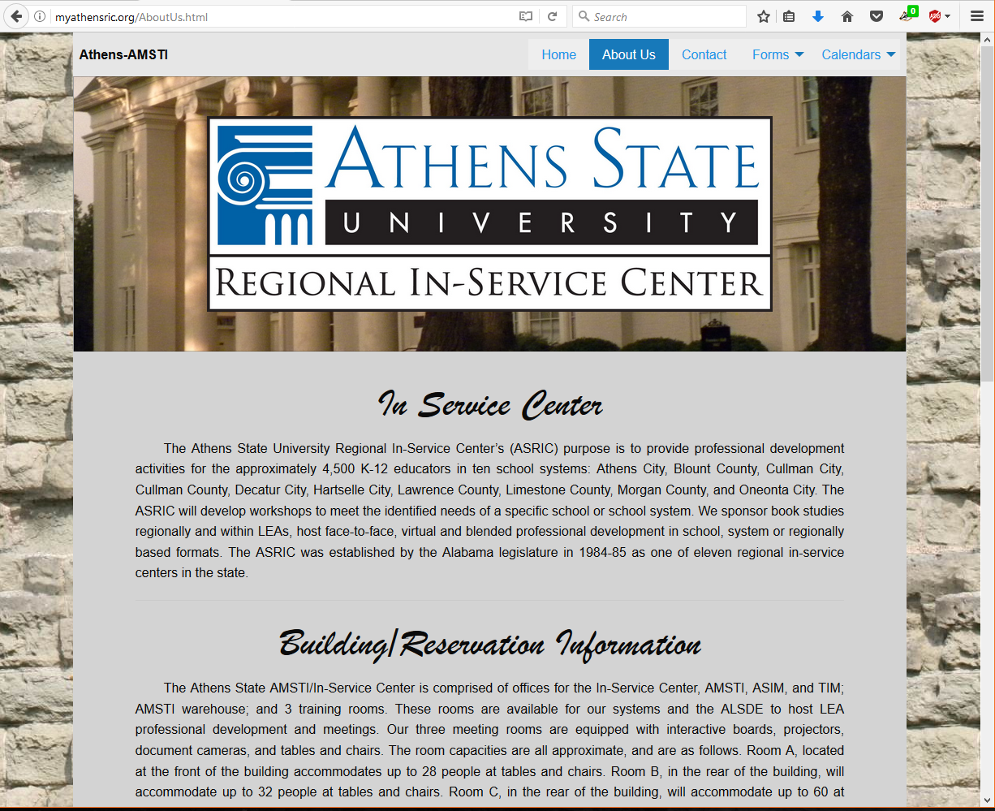

Figure – The About Us page. Note: You will have to scroll down to view its entire contents.

The Contact page contains the contact information for all of the employees of the local AMSTI Organization. Here you will be able to find the phone number and email address of the staff.

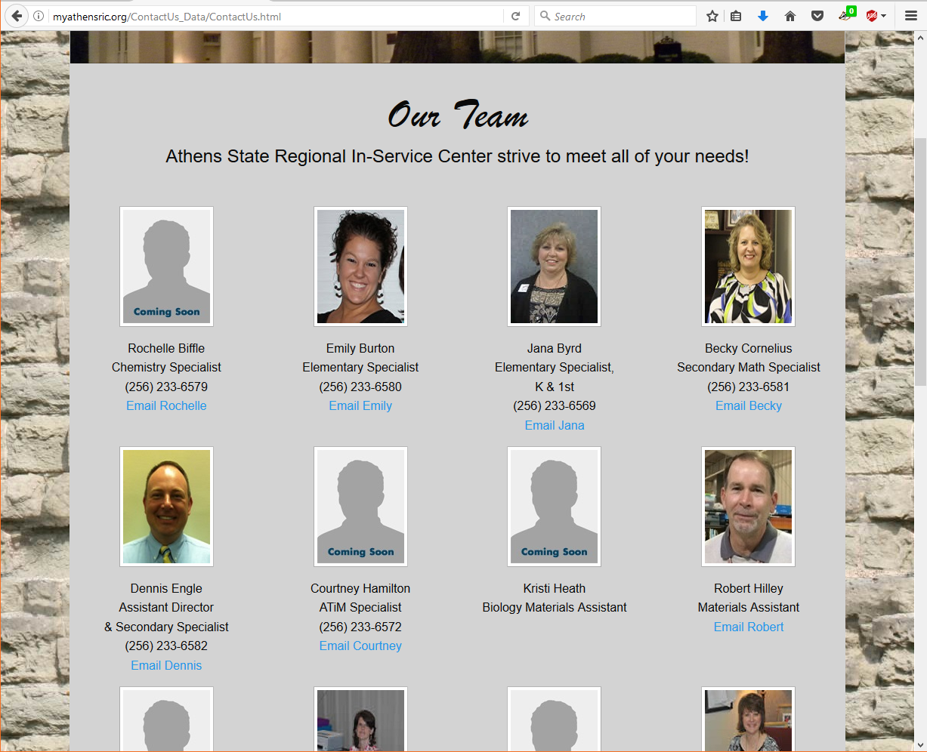

Figure - The Contact page. Note: You will have to scroll down to view its entire contents.

The forms link is where you can find the forms required for making a reservation or request. Simply move your mouse pointer over the forms link. Click on the desired form. A new tab will open in your browser.

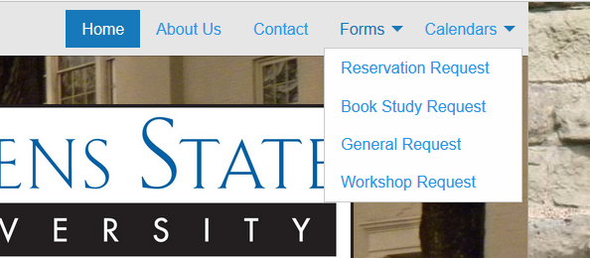

Figure 5 - The Forms link.

The form that opens is dependent on which link you click on.

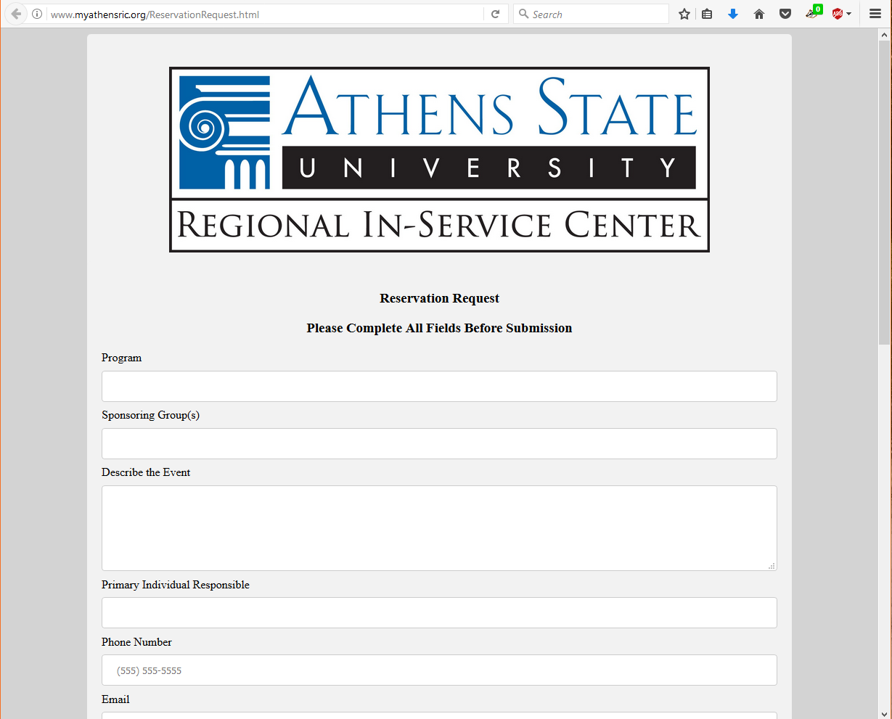

Figure 6 - The Reservation Request form.

Please fill out the form in its entirety. You will not be allowed to submit the form until all required fields have been filled in. This is the case for all forms.

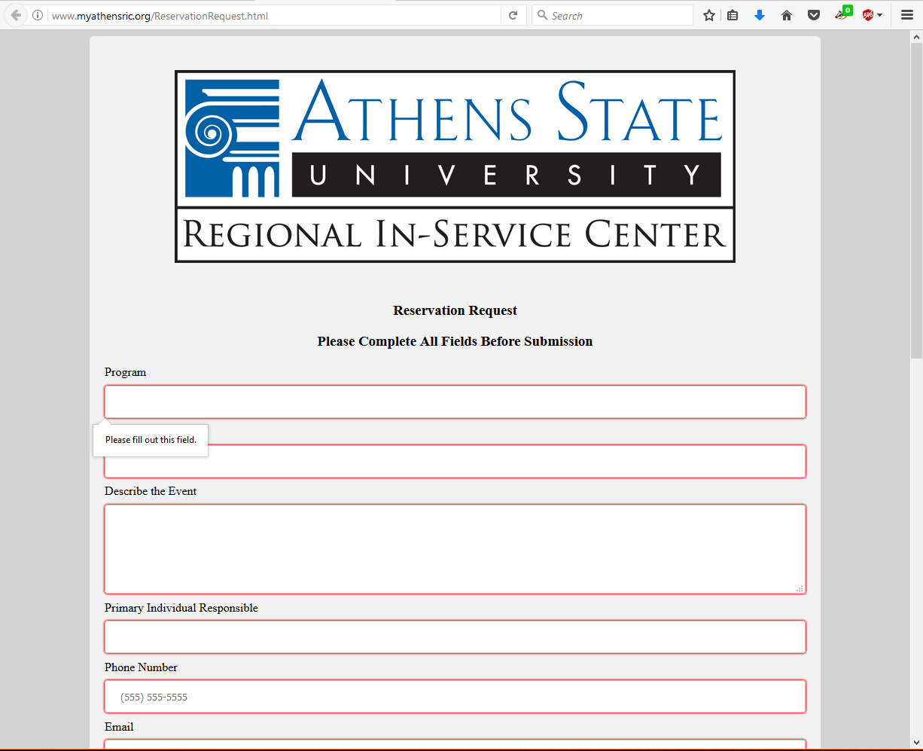

Figure 7 – Field validation.

Upon submission, you will get a message. You can now safely close the tab. You will receive an email confirming or denying your reservation.

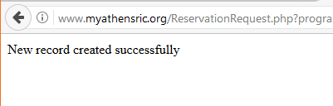

Figure 8 – Confirmation message.

To view the schedule, place the mouse pointer over the calendar link. This brings up links to the individual rooms. Click on the desired room.

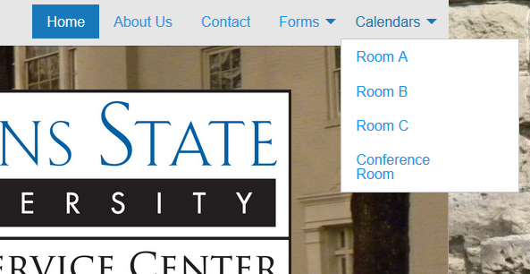

Figure 9 - Calendar links

Clicking on a calendar will bring up a page showing the available dates that are not booked. Calendars are hard coded in the website to upload whenever someone modifies the google calendar.

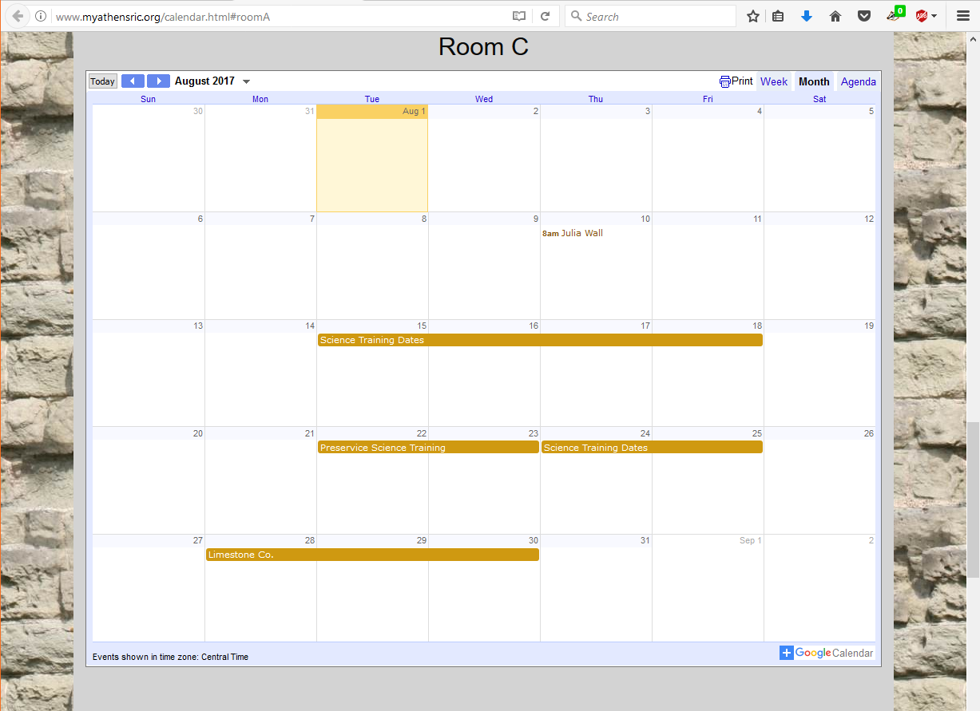

Figure 10 - Calendar for room C

# **AMSTI Site Map**

* <http://myathensric.org/Home.html>
* <http://myathensric.org/AboutUs.html>
* <http://myathensric.org/ContactUs_Data/ContactUs.html>
* <http://www.myathensric.org/ReservationRequest.html>
* <http://www.myathensric.org/BookStudyRequest.html>
* <http://www.myathensric.org/GeneralRequest.html>
* <http://myathensric.org/WorkshopRequest.html>
* <http://www.myathensric.org/calendar.html#roomA>
* <http://www.myathensric.org/calendar.html#roomB>
* <http://www.myathensric.org/calendar.html#roomC>
* <http://www.myathensric.org/calendar.html#roomConf>

# **Web Service Access**

To edit the webpages, go to <http://www.ipower.com> and click LOGIN in the upper right.

See Dr. Lewis for username and password information.

Click “FileManager”, then select “public_html” in the left frame to see the folders and files used to make up the website. The icons next to the files can be used to:

* pencil to edit files
* magnifying glass to view the page in your default browser
* arrow to download files

To view or edit the database schema and contents, on the iPower homepage, click “MySQLDatabase”. Under Databases, click “accounts” to edit Amsti Login data or “Amsti_01” to edit the Amsti forms submission data.

Click the icon under “Access phpMyAdmin”. This takes a while to load. Click on the tables in the upper left to view or alter the schema or contents.

The accounts database has two tables:

* newsletter_emails
* users

The accounts database connection properties are:

* Host: myathensricorg.ipowermysql.com
* See Dr. Lewis for username and password information

The amsti_01 database has four tables:

* tblBookStudyRequest
* tblGeneralRequest
* tblReservationRequest
* tblWorkshopRequest

The amsti_01 database connection properties are:

* Host: myathensricorg.ipowermysql.com
* See Dr. Lewis for username and password information.

# **The Forms Database**

When data is entered on a form and submitted, the data is passed to the corresponding PHP page, which parses the data and inserts it into the database. The database contains a table for each of the forms with fields that correspond to the fields on the forms.

If the data is successfully inserted into the database, an email is sent and a message is displayed that the record was successfully inserted into the database. One or more email addresses will need to be chosen to receive the submission emails. Also, the confirmation message should be developed to include e.g. a popup message box.

A report of what is in each table can be viewed from the Report PHP pages. These will need to be developed further to capitalize on the full power of querying the database tables.

The username for the database is amsti_01 and the password is Capstone@17. The URLs for the report pages are:

* <http://myathensric.org/BookStudyReport.php>
* <http://myathensric.org/GeneralReport.php>
* <http://myathensric.org/ReservationReport.php>
* <http://myathensric.org/WorkshopReport.php>

# **Newsletter**

The newsletter on the home page can be changed by uploading a new PDF file to Google Drive.

To upload a newsletter:

1. Login to your google drive account
2. Upload newsletter pdf to google drive
3. Once uploaded right click and select ‘Share with others’
4. Copy the link and paste the link into the iframe scr=”” on the home.html code